# Install SBT

1. Open Intellij , go to File>>Settings…
2. Select plugin and search for scala

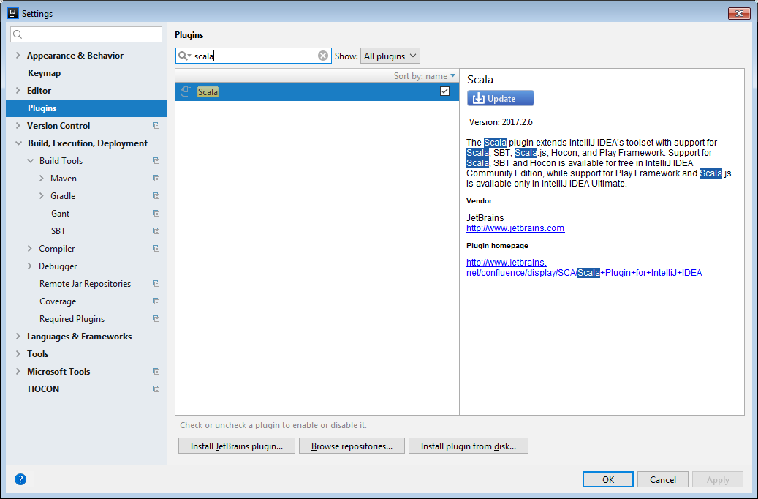

1. Install Scala plugin (it includes sbt also) and restart Inttelij
2. Now Create new Project by selecting File>>New>>Projects..

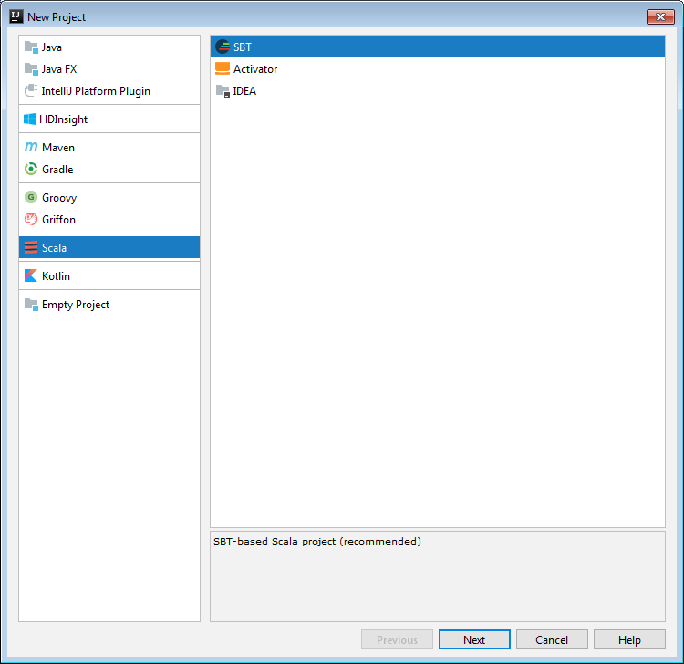

Choose Scala>>SBT and click on Next

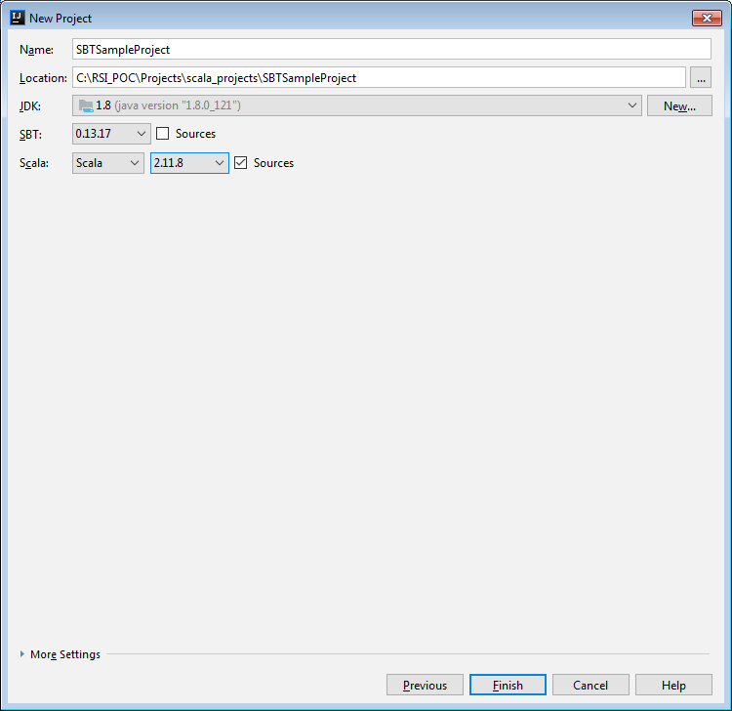

Choose proper Scala Version (I selected 2.11.8), click Finish

Wait for some time, it will take some time to configure SBT project

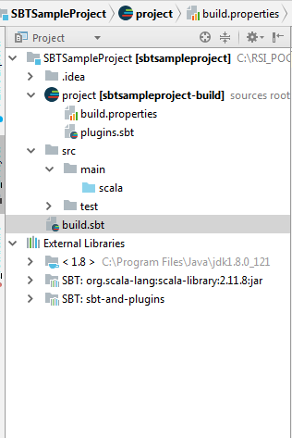

You will see folder structure like above

Place mouse bottom left and select SBT, you will see SBT Tasks at Upper right corner

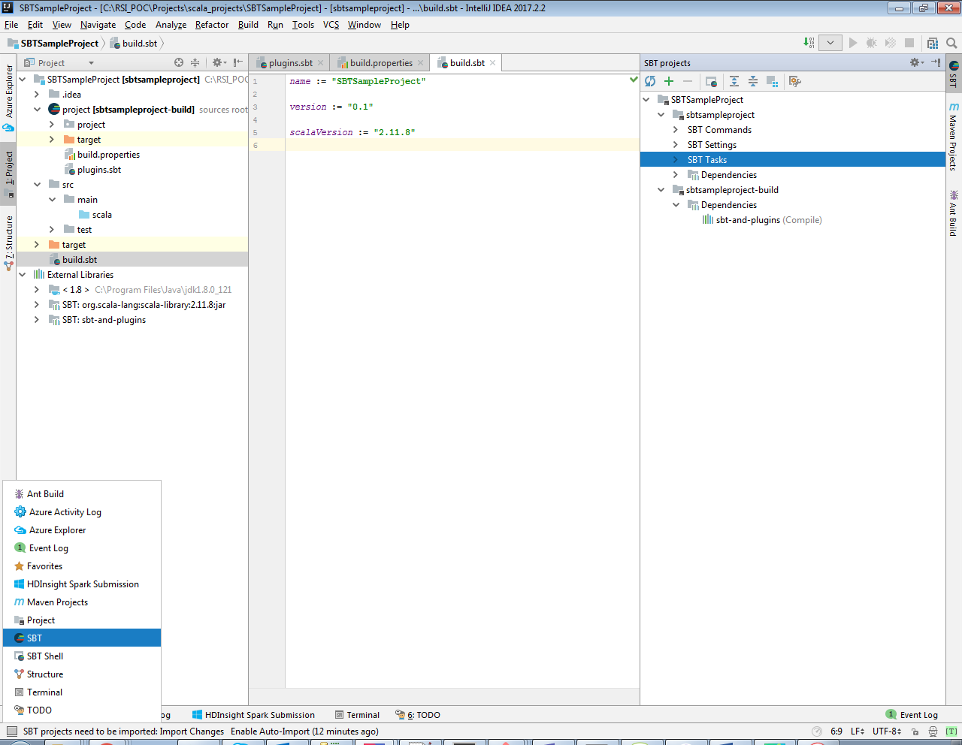

Expand SBT Tasks

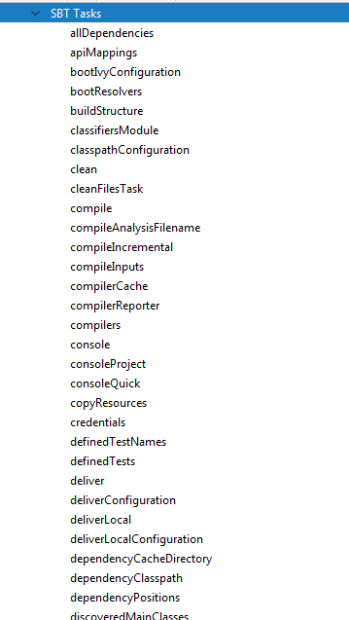

You won’t find assembly option here, assembly plugin is used for creating fat jar

To enable assembly plugin, do the following steps

Setup to Create fat jar

Under plugin.sbt put following line

addSbtPlugin(**"com.eed3si9n"** % **"sbt-assembly"** % **"0.12.0"**)

click on Refresh project after that and wait for some time

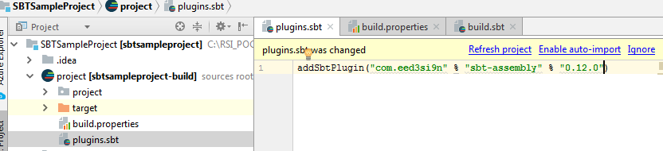

Now Again check SBT Tasks, you will find Assembly options

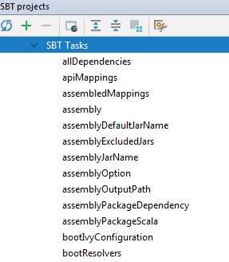

Note: if you won’t find assembly options, try to add assembly.sbt instead of plugins.sbt file

Added below code under build.sbt

|  |
| --- |
| *name* := **"SBTSampleProject"** *version* := **"0.1"** *scalaVersion* := **"2.11.8"** *libraryDependencies* ++= *Seq*(  **"org.apache.spark"** % **"spark-core_2.11"** % **"2.1.0"** %**"provided"** ,  **"org.apache.spark"** % **"spark-sql_2.11"** % **"2.1.0"** %**"provided"** ,  **"com.typesafe"** % **"config"** % **"1.3.1"**,  **"com.typesafe.scala-logging"** %% **"scala-logging"** % **"3.7.2"**,  **"org.scalatest"** %% **"scalatest"** % **"3.0.4"** % **"test"** )  *// to skip Test Cases at the time of creating fat jar test* in *assembly* := {}  *//to exclude scala packages in fat jar assemblyOption* in *assembly* := (*assemblyOption* in *assembly*).value.copy(includeScala = **false**)  *// to discard duplicate files assemblyMergeStrategy* in *assembly* := {  **case** *PathList*(**"META-INF"**, xs @ _*) => *MergeStrategy*.*discard* **case** x => *MergeStrategy*.*first* } |

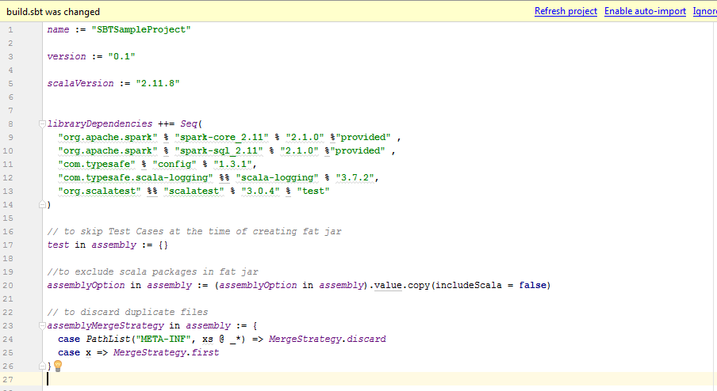

Refresh project

Now create fat jar, either you can directly click on assembly under SBT Tasks

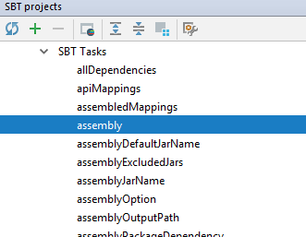

Or you can create new SBT Tasks by using below steps

Choose Edit Configurations… at upper right corner

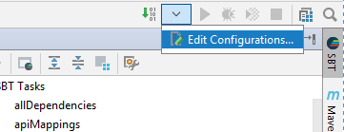

Click + button and select SBT Task

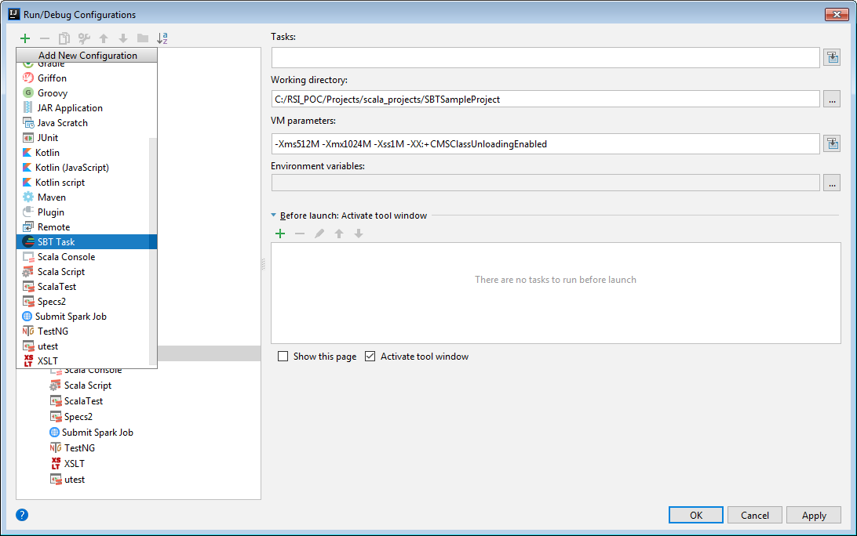

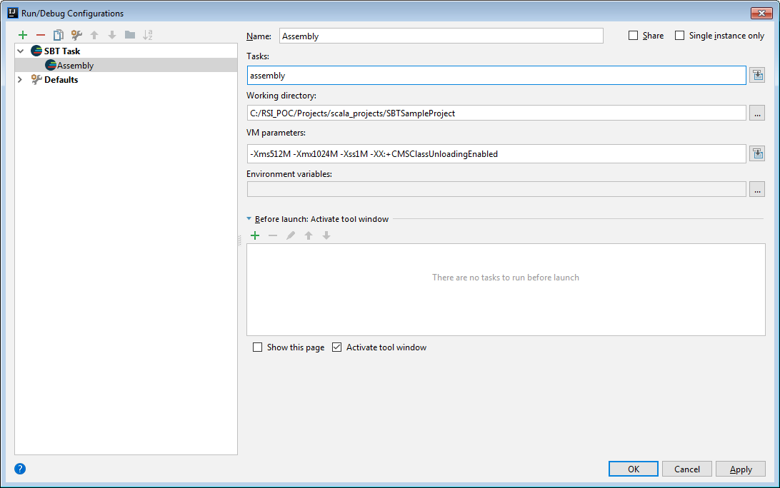

Define Proper Name and Tasks as assembly and click Apply and OK

Now You can run Assembly by clicking on play button

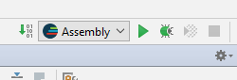

By creating assembly option, we have leverage to stop it in between suing stop button

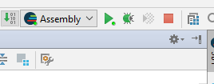

To build plain jar you can choose package option from SBT Tasks or can create new package task same as we created assembly task